

FINAL PROJECT REPORT

DIGITAL VAULT

2022

Rashid Ali (023-21-0338)

Amir Ali (023-21-0339)

**Introduction:**

We use several websites on a daily basis as a result of the rising use of the internet, and practically every website, from social media apps to business banking apps to academic sites, requires us to register a user account and choose a password. With dozens of passwords, the human memory can't keep up. Because of the amount of harm that can be done when a login credential is compromised, password security has remained one of the most essential areas of IT security since then. As a result, the major motivation for developing this application, is that it will allow quick access to all passwords in one location.

**Problem Statement:**

The user can’t come up with a unique and strong password every time, so they prefer to use the same password for almost all the accounts or they just choose an easy password or write passwords and login details on their notebooks. Hence, a user can easily become the victim of identity theft if someone gets access to their login details. Thus, managing all the passwords and login details of a user securely is the primary reason behind creating this application.

**Proposed Methodology:**

We plan to develop this application by applying all the Object-Oriented concepts we’ve learned in this course to maintain the code reusability and simplicity. Moreover, we plan to design a decent graphical user interface with the help of Swing and Abstract Window Toolkit (AWT) and exception handling will be used in order to counter all the errors that may lead to unpredictable behavior of the application. We will be using Java Data Base Connectivity (JDBC) in this project to store, fetch and update the credentials of the user.

**Major Outcomes:**

By using this application, users can get all of their login credentials at a single place hence the users will be freed from the fear of forgetting their important login credentials. This will also solve the problem of reusing the same password for all the accounts because users will have to remember just a single master password to access all the credentials of their important accounts. Moreover, this application will also save the time a user spent on resetting passwords.

**Implementation:**

The application is developed successfully by using the technologies laid in the project proposal, Swing and Abstract window toolkit(AWT) is used for GUI and handling events, Structure query language (SQL) is used to store data, and object oriented programming (OOP) concepts are used to make the code readable and reusable. The Application provides the user the privileges to o add, search, generate, or update the password of any account. The user can store as many passwords as they require. Users can gain access these features by making an account in the application, entering a username and password on the sign up page, and then logging in with the same username and password on the login page. After logging in, the user can access the dashboard to add a new account password, search for, generate, or alter the password for an existing account in the application. A Diagram is provided below for better understanding of the flow of the application.

**Login**

**Add Password**

**Generate**

**Password**

**Search**

**Update**

**Password**

**Logout**

**Sign up**

**D**

**ashboard**

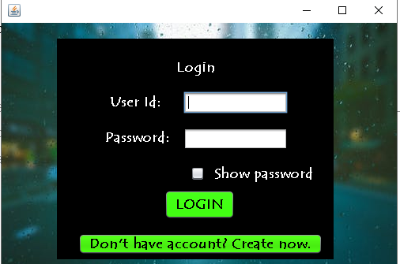We'll start with the login page; as soon as you open the app, you'll be provided with a form that allows you to login in to the digital vault; the buttons on the side allow you to select between logging in and signing up as a new user; let's start with the signup page.

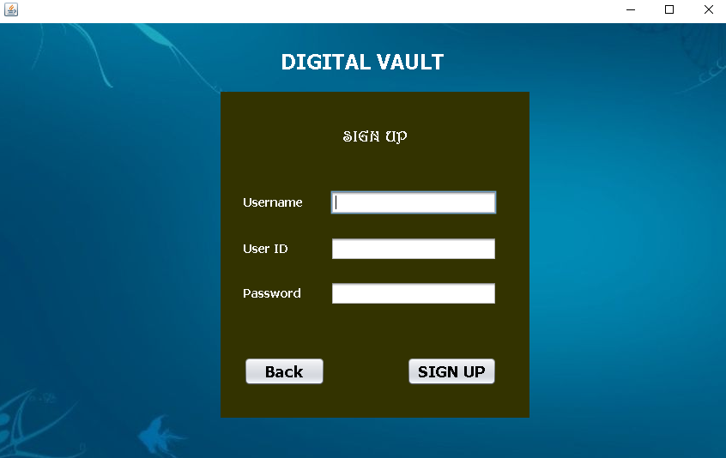

You need to enter your username, user id and password in the text fields provided and then click signup. After clicking signup, the username, user id and password will be saved in the database, and we will be able to retrieve them in order to login. A user id may not be used more than once.



After sign up, login main portal appears. To login, you must provide the correct user id and password. When you click the login button, the provided username and password will be checked through the database, and if it matches any record the person will be logged into digital vault.

After logging in, you will be presented with a dashboard in which there are four options:

* Add Password
* Generate Password
* Search Password

➢ Update Password

* Logout

These will provide you the facility to add, generate, update or search password of your account.

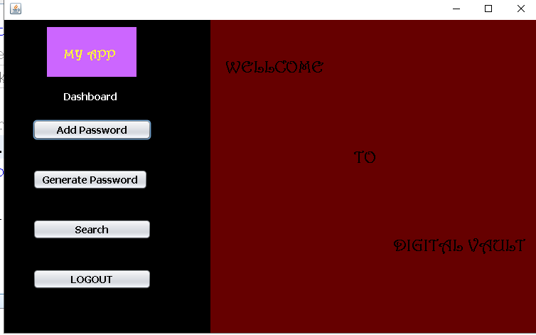

After clicking 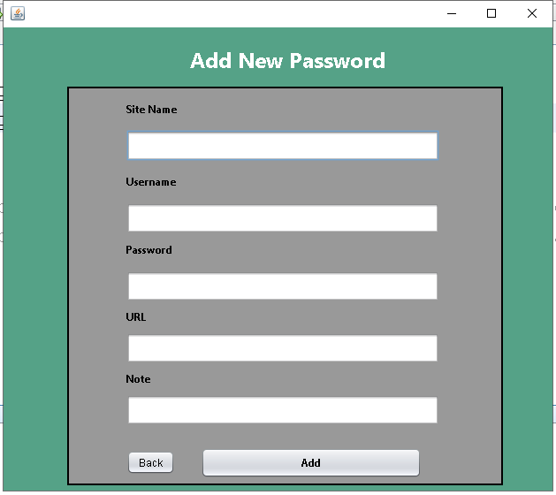“**Add new password”,** you will be presented with a form which will let you add account of any of your site. It requires Site name, username, password, optional URL and addition note. Site name, username and password are mandatory fields. If you miss to enter input in any these fields then it won’t proceed further and show you a dialog box to enter in that particular field. Upon hitting the add button, the password is stored into the database.

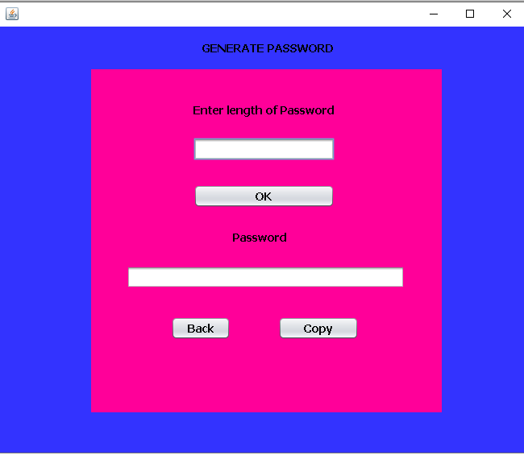

In the dashboard, you have option of “generate password” in which you will be provided with this form in which you need to enter length of password then click ok. After clicking ok, password will be randomly generated for your account and you can copy this and paste it into add password for storing new password and then clicking back to get back to the dashboard.

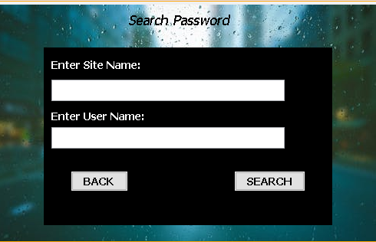Search Password is where you can search your existing password that you stored in the application. Here you will enter your account name and username that you added in the “**Add password portal “.** After entering details in the given text fields, click on search button. This button will check details in the database and if it matches then it will let you enter in another form that is called **update password**.

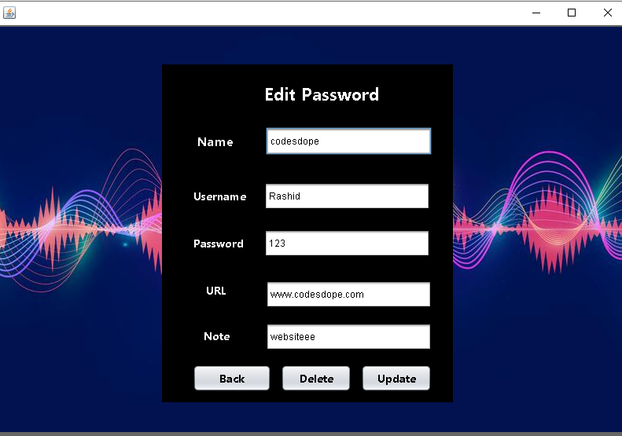After clicking search button, you will be provided with this form that is update password or edit password. Whatever account name you searched in the “**Search password portal**” the password and all the details of that account will be visible on this form. Now it is your wish if you want to

Update it, delete it or just note that password and get back on dashboard by clicking on the

**“Back”** button. After clicking back button, click on the **“logout”** buttonon dashboard for closing all the connection and it take you back on login page.

**CONCLUSION:**

As we know that today’s digital life requires so much privacy. Every kind of platform or website needs our credentials to create an account and make it accessible only for us. But it is not humanly possible to remember such a huge number of login credentials. The project named “Digital Vault” will be useful to make it easy for anyone to store and retrieve any credential information in such a user friendly and secured platform. User would only have to remember one master password to access all the functionality of this program. This application would also suggest the User any random passwords while creating any account and stores them automatically, if approved.